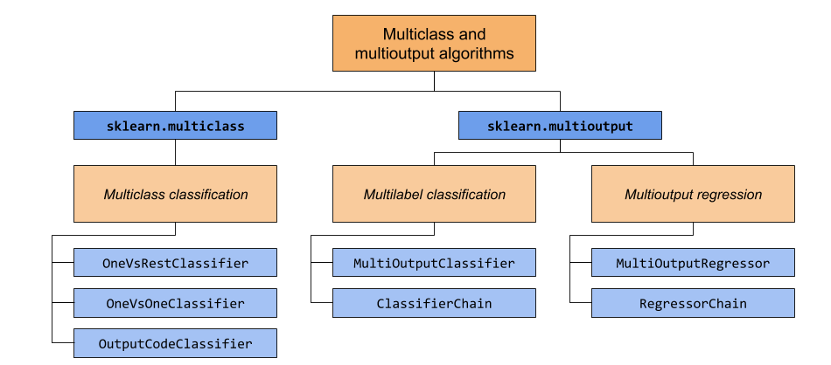

**Fig. 1.1.** Cathegories of algorythms for multi-learning problems (Pedregosaet al. 2011)